1. Login to Putty as root ensure that you are in this directory /usr/hdp/current/phoenix-client/bin
   1. Type in python sqline.py to get into Phoenix Prompt
   2. Create table (Need to have PRIMARY KEY)
      1. CREAT TABLE user(USERID INTEGER NOT NULL, AGE INTEGER, GENDER CHAR(1), OCCUPATION VARCHAR, ZIP VARCHAR CONSTRAINT pk PRIMARY KEY(USERID))
      2. !tables to check
   3. Quit Phoenix
   4. Go back to home directory: cd /home/maria_dev
   5. Ensure that you have ml-100k directory
      1. mkdir ml-100k
      2. cd ml-100k
      3. wget <http://media.sundog-soft.com/hadoop/ml-100k/u.user>
      4. cd .. for home directory
   6. Get the pig script
      1. wget <http://media.sundog.soft.com/hadoop/phoenix.pig>
      2. 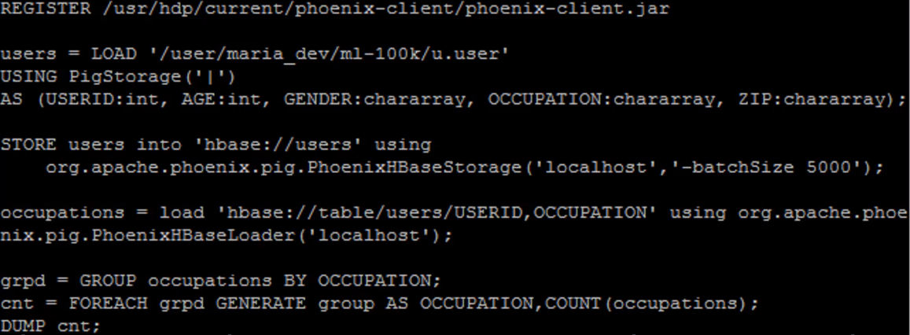less phonenix.pig
2. Loading up the user – Line 2 -4 (ensure that each data type match the column data types)
3. Store it into hbase – Line 5-6
   1. Hostname and batchsize 5000, means 5000 entries then commit them all. Ensure that you don’t exceed the memory usage
4. Only load back to userid and occupation column Line 7-8
   1. Using the PhonenixHBaseLoader class
5. Doing query on it. Line 9-11
   1. grpd = Group everyone that has the same occupation
   2. Each group, them by the occupation and their count
6. Run the script
   1. pig phoenix.pig

Clean up

1. go back to the folder: cd /usr/hdp/current/phoenix-client/bin
   1. python sqline.py
   2. !tables
   3. DROP TABLE users
   4. !tables!quit

Shutdown HBASE